MotorLease Application Deployment Instructions.

Visual Studio

Open Visual studio with admin privileges (Run as admin)

Visual studio will provide you with a prompt to open a solution. Locate the project and open it.

After the application opens, ensure that it builds successfully.

First, build while it’s on debug mode:

On successful build, switch the mode to Release. This will allow to build and **Publish** for production.

On the solution explorer, right click on the project and click on publish. The following tab will open.

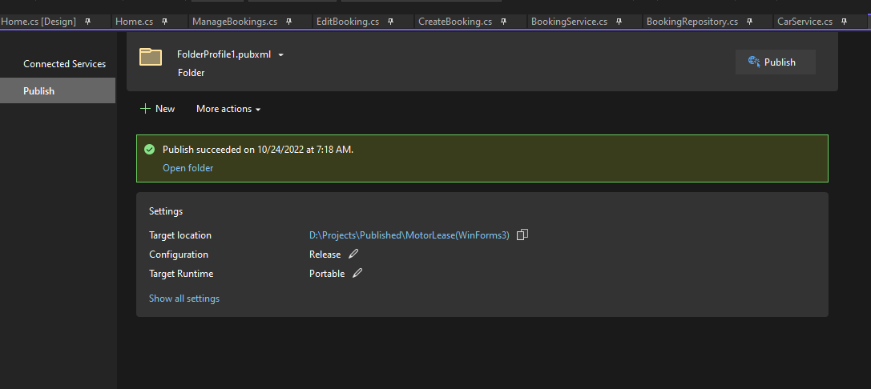

Click **New** and follow the instructions to publish your application to your selected folder.

**Points to Note**

Ensure that you have the .NET runtime required for the application to run, installed on the environment intended for running the application.

Before building and publishing the application, ensure to change the application configuration to match the target environment (In this case, SQL Server Connection and Database)

* In the solution explorer, find the configuration file (App.Config), and make the changes as highlighted below:

* Replace the” **Data Source”** value with your own.

Once the application has published successfully, go the target folder and voila!